ESKA® Insures

Credit Insurance

Business Processes Document

ESK/INS-20:0023 Uen

Prepared By



Proprietary and Confidential

Copyright 2019 by ESKADENIA Software
All Rights Reserved.

Contents

1 Credit Insurance Processes 6
1.1 Business Entity Profile Creation Process 6
1.1.1 Business Entity Profile Creation Flow Chart 7
1.1.2 Business Entity Profile Creation Flow Description 8
1.2 NBI Submission Process 9
1.2.1 NBI Submission Flow Chart 10
1.2.2 NBI Submission Flow Description 11
1.3 Application Registration Process 14
1.3.1 Application Registration Flow Chart 16
1.3.2 Application Registration Flow Description 17
1.4 Credit Information Process 20
1.4.1 Credit Information Flow Chart 21
1.4.2 Credit Information Flow Description 22
1.5 ST Application Evaluation Process 23
1.5.1 ST Application Evaluation Flow Chart 24
1.5.2 Credit Risk Assessment Flow Description 25
1.6 Investment Pre-Assessment Process 26
1.6.1 Investment Pre-Assessment Flow Chart 27
1.6.2 Investment Pre-Assessment Flow Description 28
1.7 FII/Investment Application Evaluation Process 29
1.7.1 FII/Investment Application Evaluation Flow Chart 30
1.7.2 FII/Investment Application Evaluation Flow Description 31
1.8 Policy Offer and Issuance Process 33
1.8.1 Policy Offer and Issuance Flow Chart 34
1.8.2 Policy Offer & Issuance Flow Description 35
1.9 Policy Renewal Process 36
1.9.1 Policy Renewal Flow Chart 37
1.9.2 Policy Renewal Flow Description 38
1.10 Endorsements Process 39
1.10.1 Endorsements Flow Chart 40
1.10.2 Endorsements Flow Description 41
1.11 Notification of Probable Loss Process 42
1.11.1 NPL Submission Flow Chart 43
1.11.2 NPL Submission Flow Description 44
1.12 Claim Submission Process 46
1.12.1 Claim Submission Flow Chart 47
1.12.2 Claim Submission Flow Description 48
1.13 Overall Credit Limit (OCL) Process 50
1.13.1 Overall Credit Limit Flow Chart 51
1.13.2 Overall Credit Limit Flow Description 52
1.14 Individual Credit Limit (ICL) Process 53
1.14.1 Individual Credit Limit Flow Chart 54
1.14.2 Individual Credit Limit Flow Description 55
1.15 Processes Authority Matrix 56
2 Approvals 57

Document History

Document Version | Date | Summary of Changes | By | Department
0.1 | 01.10.2019 | Document Creation | Radwan Jundi | ESK/INS
0.2 | 23.10.2019 | Proofreading/ Formatting | Ola Azzouqa | ESKA/Comm
0.3 | 23.10.2019 | Review | Laisan Mobaideen | ESK/INS
0.4 | 03.11.2019 | Update | Radwan Jundi | ESK/INS
1 | 03.11.2019 | Update & Baseline | Laisan Mobaideen | ESK/INS
1.1 | 15.11.2019 | Update | Radwan Jundi | ESK/INS
2 | 20.11.2019 | Baseline | Laisan Mobaideen | ESK/INS
2.1 | 05.12.2019 | Update; reinsurance department was renamed to reinsurance section | Laisan Mobaideen | ESK/INS
3 | 05.12.2019 | Baseline | Laisan Mobaideen | ESK/INS
3.1 | 05.01.2020 | Review | Business Owners | ICIEC
3.2 | 19.01.2020 | Review | Risk Management Div | ICIEC
3.3 | 22.01.2020 | Update | Radwan Jundi | ESK/INS
3.4 | 07.02.2020 | Update | Radwan Jundi | ESK/INS
4 | 08.02.2020 | Baseline | Laisan Mobaideen | ESK/INS
4.1 | 22.02.2020 | Update  - Risk Manager is replaced with RMD as per ICIEC Risk feedback | Radwan Jundi | ESK/INS
5 | 22.02.2020 | Baseline | Laisan Mobaideen | ESK/INS

Scope

Identification
This document shall be referred to hereafter as the business processes to accommodate with ESKA® Insures – Credit Insurance.

Purpose
The purpose of this document is to provide an overview of the basic processes that are managed through ESKA® Insures – Credit Insurance, to cover the operational activities along with the interaction with the peripheral components and systems.

Definitions, Acronyms and Abbreviations
The list below contains the definitions, acronyms and abbreviations used throughout the document:

Abbreviation | Definition
CI | Credit Information
BDD | Business Development Department
NBI | Non-Binding Indication
CRM | Customer Relationship Management
UW | Underwriting
IO | Insurance Operations
ST | Short Term
MLT | Medium, Long-Term
ICL | Individual Credit Limit
OCL | Overall Credit Limit
DoA | Delegation of Authority
LoA | Letter of Acceptance
NPL | Notification of Probable Loss
PH | Policyholder
ESH | Environment/Social/Human Rights
PA | Policy Administration
RDM | Reinsurance Department
NOL | Non Objection Letter
GLC | General Legal Counsel
RDM | Risk Management Division
LT | Long Term
FII | Foreign Investment Insurance
PPCL | Policyholder Premium Credit Limit

Credit Insurance Processes

Business Entity Profile Creation Process

Purpose: Capturing relevant information in respect of prospects, policyholders, brokers, banks, etc., and subject matter including country, sector, industry, legal status, contact details, shareholders, etc. for profiling, screening, and segmentation purposes in order to identify entities trust worthy to mitigate risks and avoid losses caused by unreliable ones.

Required Documents
- Copy of commercial registration certificate
- Copy of membership of the Chamber of Commerce
- Copy of internal credit procedures manual and credit management policy
- Three latest annual reports (or audited financial statements)
- Brochure of the company and its activities

Involved Stakeholders
- Credit Information Sources
- Prospects
- Policyholders
- GLC
- BDD staff
- Brokers
- Banks

Business Entity Profile Creation Flow Chart

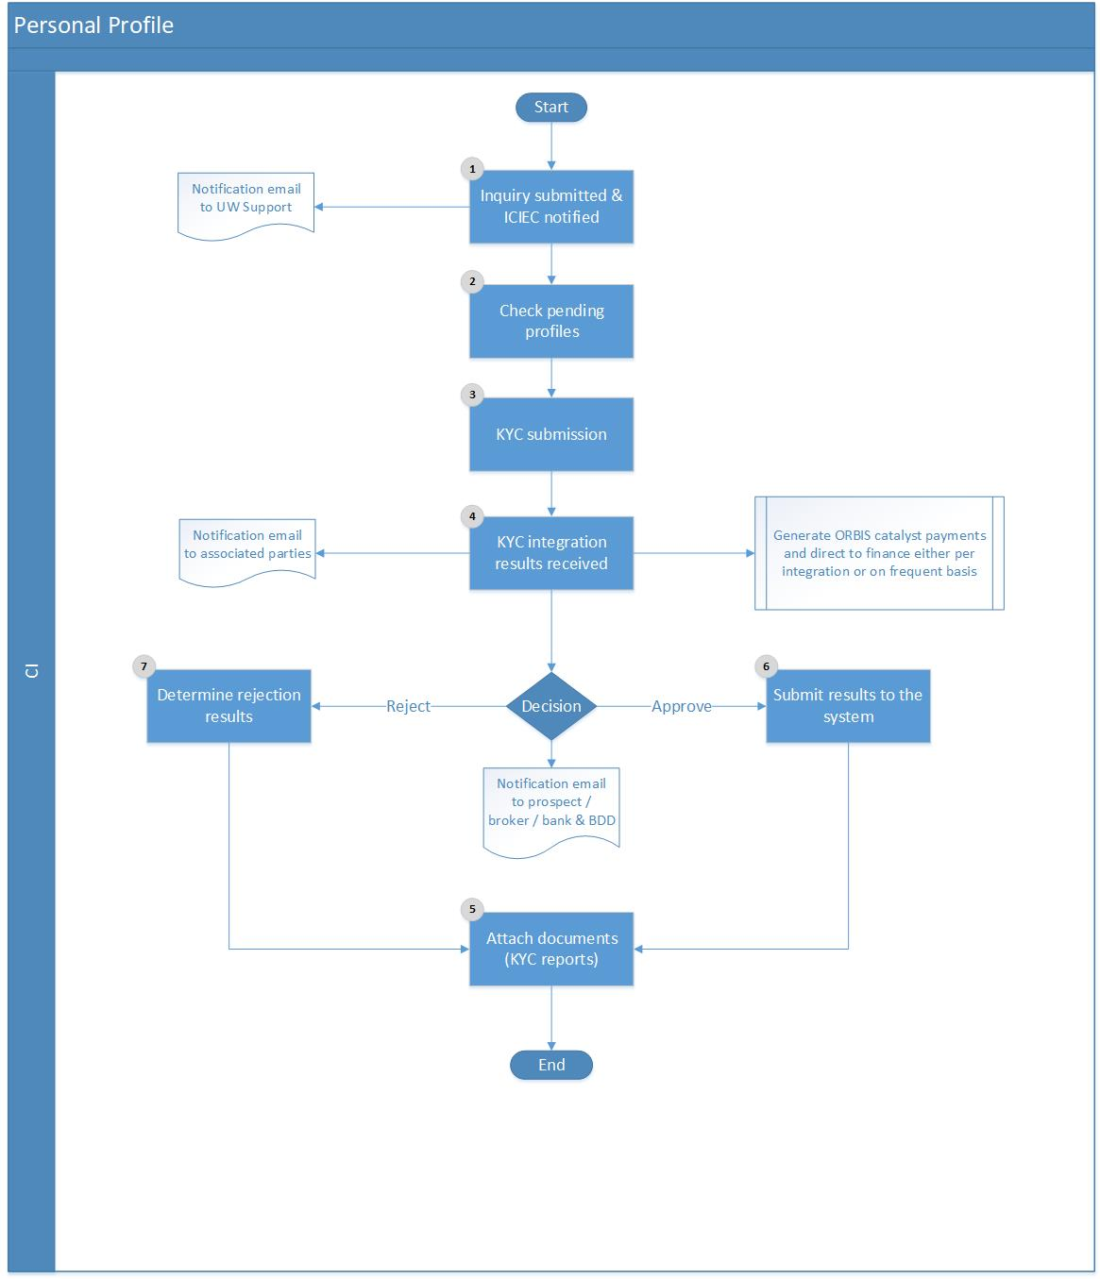
Figure ‎1-1 (Business Entity Profile)

Business Entity Profile Creation Flow Description

Step # | Stakeholder | Step | Description
1 | Broker  BDD staff  GLC | Inquiry Submission | Inquiry is submitted through the following channels (customer portal, brokers portal, bancassurance or direct access with BDD staff) and associated department is notified via automatic notification to take proper action and make necessary arrangements.
2 | Broker  BDD staff  GLC | Check Profiles | Underwriting support shall review and verify that the particular profile has no previous records and this will be facilitated utilizing system’s inquiry functionality and criteria e.g. entity name, commercial registration number etc.
3 | Broker  BDD staff  GLC | KYC Submission | At this stage, credit information sources will be contacted in order to accurately analyze the background information of the entity in terms of trust worthy to mitigate risks and search for any criminal background such as: money laundry, fraud, or international sanctions.
4 | Broker  BDD staff  GLC | KYC Results | Results are delivered by the Credit Information sources. Accordingly, respective payments shall be directed to the Financial entity to keep track of amounts payable.
5 | Broker  BDD staff  GLC | KYC Documents | Update shall be reflected at the system uploading all the provided associated documents and results yet all flagged transactions must route to GLC for clearance.
6 | Broker  BDD staff  GLC | Profile Approval | In reference to the authorized person, decision shall be applied (Green/Red flag) in the system to determine whether ICIEC may perform and proceed with arrangements with the particular entity or not.
7 | Broker  BDD staff  GLC | Profile Rejection | If a profile is rejected, rejection reasons and justification for conducting business shall be defined and proper notification email shall be directed to the entity concerned and BDD.

NBI Submission Process

Purpose: The non-binding indication letter is a term sheet sent to the clients during the process of registration for new insurance policies provided by ICIEC. Clients are required to review it carefully and approve as an acceptance of the cover policies. NBI refers to indicative terms and conditions under which ICIEC would consider providing insurance coverage in respect policies linked to countries’ capacity. Once the terms are accepted by the client, ICIEC will make the necessary recommendations and negotiations internally to finalize the policy contract.

Required Documents
- Application Form
- All other required documents submitted by client with the application form

Involved Stakeholders
- Policyholder
- Broker
- Agency
- Bank
- Underwriting Support
- Underwriting Department
- Country Manager
- Senior Country Manager

NBI Submission Flow Chart

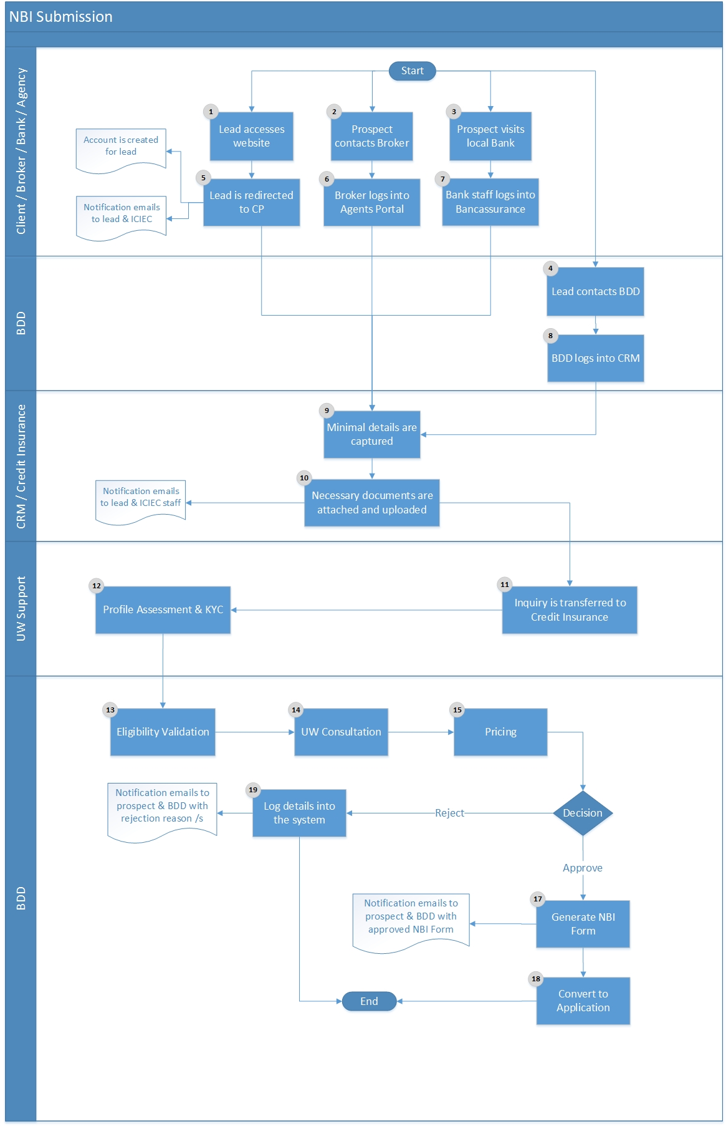

Figure ‎1-2 (NBI Submission)

NBI Submission Flow Description

Step # | Stakeholder | Step | Description
1 | Client | Contact | Lead (prospect client) accesses ICIEC website to check offered products and coverage.
2 | Client | Contact | Prospect client contacts broker to inquire about insurance coverage.
3 | Client | Contact | Prospect client visits local bank to receive financing for operations and expand business.
4 | Client | Contact | Prospect client contacts business development staff to inquire about insurance coverage.
5 | Client | Customer Portal | Prospect client is directed to ICIEC online customer portal; once online account is created, lead information and details are captured and automatic notification emails are sent to ICIEC associated departments.
6 | Broker | Agents Portal | Authenticated broker logs into the Agents Portal to submit prospect client information and details.
7 | Bank | Bancassurance | Authenticated bank logs into the Bancassurance to submit prospect client information and details.
8 | BDD | CRM | Business Development staff logs into ESKA® CRM to submit prospect client information and details.
9 | Client | Customer Portal | Minimal details are captured as with reference to the entity’s standing, contact persons, legal status, shareholders, etc. and insurance coverage interest.
9 | Broker | Agents Portal
9 | Bank | Bancassurance
9 | BDD | CRM
10 | Client | Customer Portal | All necessary documents are captured and uploaded in the respective system for future reference.
10 | Broker | Agents Portal
10 | Bank | Bancassurance
10 | BDD | CRM
11 | ICIEC | Integration | All details and documents are transferred to ESKA® Credit Insurance for further processing with automatic notifications to relevant parties.
12 | UW Support | Profile Assessment | UW support will perform necessary profile assessment in conduct with Credit Information sources.
13 | UW Support | Eligibility Validation | Once results are delivered by Credit Information sources and assessment is accomplished, eligibility is determined whether to proceed with the NBI submitted or reject.
14 | BDD | Consultation | Underwriting is performed to identify, evaluate, and assess all political, commercial, and/or country risks involved. In parallel, for ST products, check has to take place to ensure that full reinsurance placement in the treaty is available while for MT/FII, if needed, engage reinsurance function to check on reinsurance market appetite.
15 | BDD | RDM | RMD to make available the sector, country and overall risk management guidelines and thresholds. Based on RMD high level guidelines, underwriting assessment shall be performed.
16 | BDD | Pricing | Having performed and accomplished the necessary evaluation process identification of proper pricing terms, applicable fees, loading, and discounts are determined to specify the proposed premium details as with reference to the Delegation of Authority Matrix.
17 | BDD | Generate NBI | Upon approval, NBI documents will be generated and emailed to the client for review and feedback bearing in mind that associated Account Manager will also receive notification for the approval.
18 | BDD | Convert | If all communications are finalized and NBI is approved from both ICIEC and client, then it is converted to Application stage (application registration) for further and detailed processing.
19 | BDD | Reject | Upon rejection, reasons have to be submitted in the system and automatic notifications with detailed explanation shall be delivered to the client bearing in mind that associated Account Manager will also receive notification for the rejection.

Application Registration Process

Purpose: Once the NBI terms are accepted by the client, ICIEC will make the necessary recommendations and negotiations internally to finalize the policy contract which starts with the application registration whereby additional details are captured and further evaluation occurs. For all policy types, underwriting department director has to ensure that reinsurance placement is in place before policy issuance; if not, reinsurance function has to be engaged for necessary action.

Required Documents
- CSTP
  - Online application

- STP
  - Online application
  - Buyer information
  - Memo on project
  - Business plan with cash flow projection (if any)

- BMP
  - Online application
  - Recent audit financial statements
  - Copy of standard contract used for financing trade

- DCIP
  - Online application

- Investment
  - Investor’s latest audited annual financial statements
  - Latest audited annual financial statements of the investor’s ultimate parent company
  - KYC Report on the investor and the applicant
  - Project feasibility studies, including cash flow projections and market analyses
  - All documents related to the investor’s contribution to the enterprise: (shareholder’s Agreement, Joint venture agreement, management agreement, technical assistance agreement and loan guarantee agreement)
  - Latest audited annual financial statements
  - All contracts relating to any non-equity direct investment: (production-sharing contract, lease agreement and operating agreement)
  - All agreements with the host government and its agencies
  - Approvals issued by the host government and its agencies
  - Guarantee issued by the host government and its agencies
  - All other agreements between the enterprise and third parties relating to this project on which the viability of the project is dependent

Involved Stakeholders
- Policyholder
- Broker
- Agency
- Bank
- Underwriting Department (PA)
- Country Manager

Application Registration Flow Chart
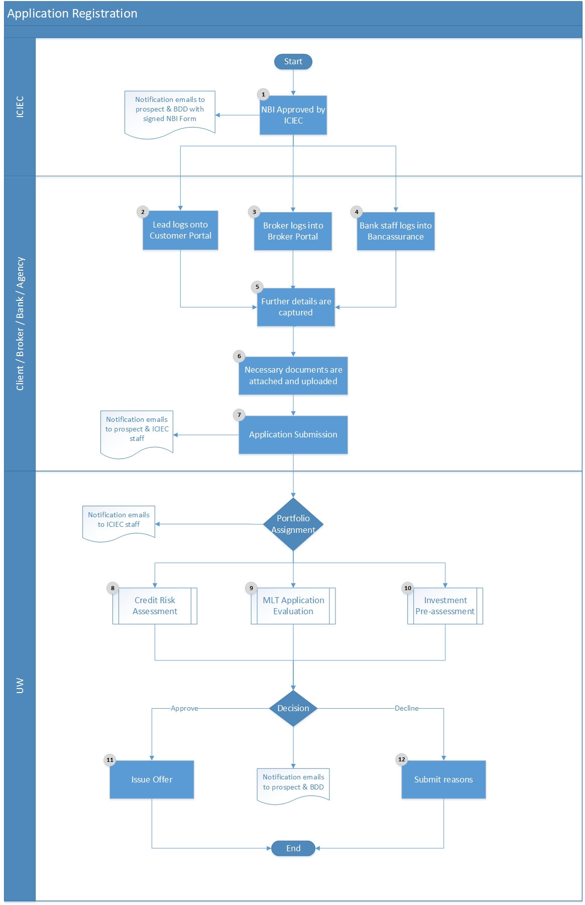
Figure ‎1-3 (Application Registration)

Application Registration Flow Description

Step # | Stakeholder | Step | Description
1 | ICIEC | NBI Approved | Upon completion of NBI processing and approval of both ICIEC and client, notification emails will be directed to all stakeholders with signed form.
2 | Client | Customer Portal | Client logs to online portal with credentials.
3 | Broker | Agents Portal | Authenticated broker logs into the Agents Portal.
4 | Bank | Bancassurance | Authenticated bank logs into the Bancassurance.
5 | Client  Broker  Bank | Portals | Additional details and required information needed for assessment and decision are captured.
6 | Client  Broker  Bank | Portals | Required documentation is attached and uploaded bearing in mind that the necessary documents differ with reference to the insurance coverage and tenor requested.
7 | System  (Automatic) | Notifications | Upon submission of all details and documents, automatic notification emails are delivered to relevant stakeholders (client and ICIEC staff). Accordingly, application is associated and assigned to a specific Credit Information (UW Support), Underwriter, Policy Administrator, and Account Manager respectively to follow-up throughout the various phases.
8 | UW (CI) | Credit Assessment | Credit risk information will obtain credit information on buyers, financial institutions, and investors for UW purposes along with recommended limits and critical notes which shall be shared with the underwriting manager for evaluation. Moreover, providing the management with periodical data on credit limits or other data. For all policy types, underwriting manager has to ensure that reinsurance placement is in place before policy issuance; if not, reinsurance function has to be engaged for necessary action.
9 | Client | Investment  Pre-Assessment | Assessment of the application will take place in accordance to eligibility criteria and further review will be considered from related ICIEC stakeholders (Reinsurance, Regional Manager, RMD and Legal Counsel). Once feedback is received, application will be submitted to the Director for decisions. Accordingly, if application is rejected then client will receive automatic notification with proper justification or a proforma invoice will be generated, directed to the Financial entity and also shared with the client in case of approval.
9 | Senior UW | Investment  Pre-Assessment
9 | UW | Investment  Pre-Assessment
9 | Assistant UW (PA) | Investment  Pre-Assessment
9 | Associate UW (PA) | Investment  Pre-Assessment
9 | IO Manager (Sovereign) | Investment  Pre-Assessment
9 | IO Manager (Commercial) | Investment  Pre-Assessment
10 | Senior UW | FII Application Evaluation | Assessment of the application will take place in accordance to RMD, reinsurance and legal counsel submissions on the system. Accordingly, non-objection letter will be generated, printed and signed to be shared with all stakeholders via email. Once finalized, due diligence mission shall be arranged and coordinated for further evaluation purposes. Before TUC, RMD will assess the overall risk perspectives and provide opinion on the transaction based on internal policies, limits, portfolio compliance and country risk. Upon completion of the mission, report and outcome will be shared and submitted to the TUC for review and decision.
10 | UW | FII Application Evaluation
10 | IO Manager  (Sovereign) | FII Application Evaluation
10 | IO Manager (Commercial) | FII Application Evaluation
10 | TUC Committee | FII Application Evaluation
11 | UW | Issue Offer | Upon approval, client and associated Account Manager will receive notification for the approval.
12 | UW | Reject Application | Upon rejection, reasons have to be submitted in the system and automatic notifications with detailed explanation shall be delivered to the client bearing in mind that associated Account Manager will also receive notification for the rejection.

Credit Information Process

Purpose: The role of credit risk information is to obtain credit information on buyers, financial institutions, and investors for underwriting purposes. Moreover, providing the management with periodical data on credit limits or other data. The credit risk information should on an annual basis monitor the credit information or in extraordinary situations like rating deterioration, an “ad-hoc monitoring” should be done.

Required Documents:
- Banks
  - KYC report
  - Latest audited financial statements
  - Updated country report with focus on banking sector

- Buyers:
- Standard credit report from approved CI source
- Basic Financial highlights
- KYC report

Involved Stakeholders
- Entity
- Assistant, Underwriter (CI)
- Associate, Underwriter (CI)

Credit Information Flow Chart

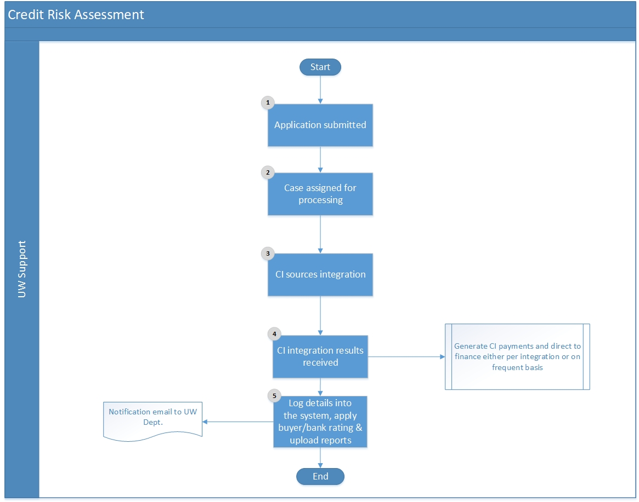
Figure ‎1-4 (Credit Information)

Credit Information Flow Description

Step # | Stakeholder | Step | Description
1 | ICIEC | Application Submission | Following the application registration process, or if the policyholder requested to add a buyer, a notification will be received on the system regarding the application.
1 | ICIEC | Revision | As a periodic exercise, on annual basis, the system will request a revision and update on the credit situation of the buyer. Following to this, a notification will be received on the system to review the OCL of previously registered buyers.
2 | Assistant, UW  Associate, UW | Assignment | Case will be assigned to personnel for credit information processing and details gathering.
3 | Assistant, UW  Associate, UW | CI Integration | ICIEC staff will contact credit information sources for necessary credit information.
4 | Assistant, UW  Associate, UW | CI Response | Once results are delivered, payments shall be generated and directed to the Financial entity to keep track of payables to Credit Information sources.
5 | Assistant, UW  Associate, UW | Log Details | According to response received, all details shall be logged onto the system, documents shall be uploaded and attached in order to properly identify the buyer/bank rating.

ST Application Evaluation Process

Purpose: Upon a short-term application submission, details and information gathering, performance of all required arrangements then evaluation of buyers/banks enlisted shall take place in order to properly and accurately assess the risks, provide appropriate coverage and limits.

Required Documents
- Banks
- Recent Financial Information
- Credit Opinion
- KYC report
- RDM country report with banking sector focus for D, E and F countries
- Exposure, commitments and country capacity report from system
- Special acceptance if above treaty

- Buyers:
- Standard credit report from approved CI source
- Basic Financial highlights
- KYC report
- At least 2 years of audited financial statements
- Updated country report from RMD
- Updated Sector report
- Trading and payment experience
- Full analysis of the financials, sector, exposure, NPL, development impact
- Shipping program by PH
- Exposure, commitments and country capacity report from system
- Special acceptance if above treaty
* Documents differ according to requested OCL

- Involved Stakeholders
- Senior Underwriter
- Underwriter
- Assistant, UW
- Associate, UW

ST Application Evaluation Flow Chart

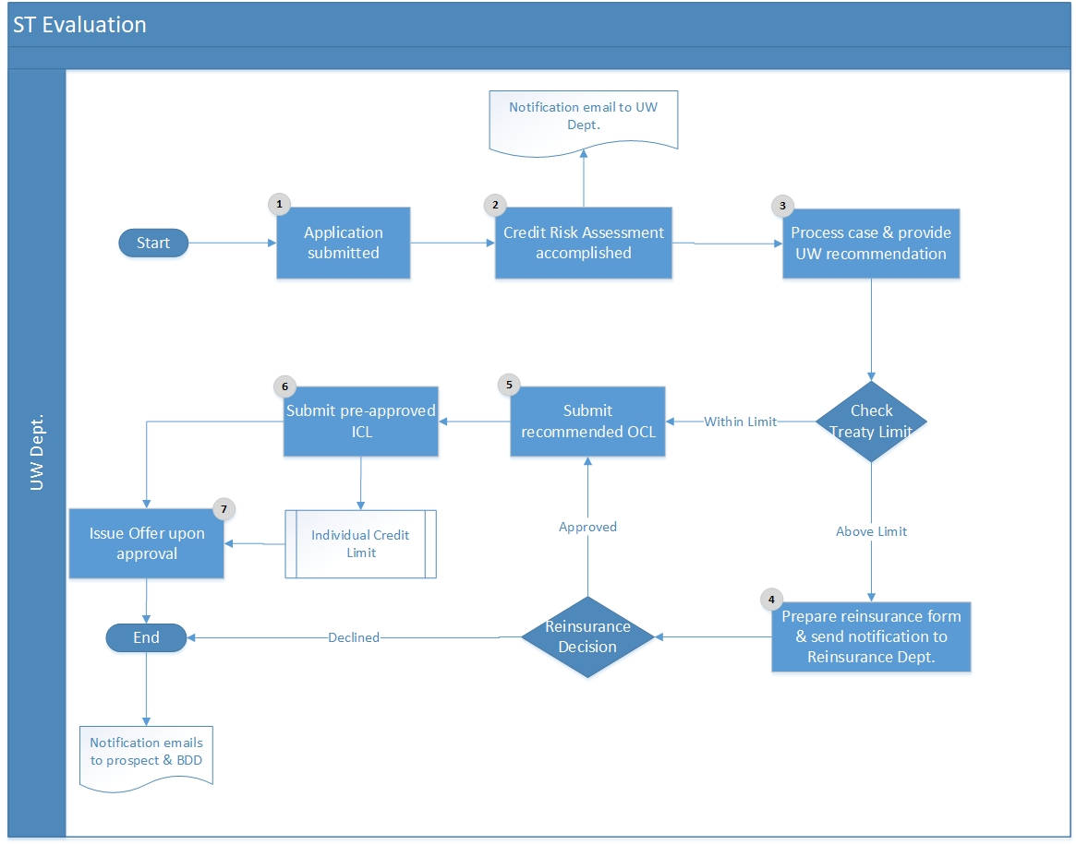
Figure ‎1-5 (ST Evaluation)

Credit Risk Assessment Flow Description

Step # | Stakeholder | Step | Description
1 | ICIEC | Application Submission | Following the application registration process or if the policyholder requested to add a buyer, a notification will be received on the system regarding the application.
1 | ICIEC | Revision | As a periodic exercise, on annual basis, the system will request a revision and update on the credit situation of the buyer. Following to this, a notification will be received on the system to review the OCL of previously registered buyers.
2 | Assistant, UW  Associate, UW | Credit Risk | ICIEC staff will contact credit information sources for necessary credit information and once results are delivered, they will be logged into the system.
3 | Underwriter  Senior Underwriter | Assessment | Underwriter will analyze all information, check previous notes (if any), perform necessary assessment, and insert UW observations along with OCL recommendation.
4 | System  (Automatic) | Treaty Limit | Automatic validation will take place to check whether recommended OCL is within treaty limit or not. If not, then automatic notification will be directed to the reinsurance function along with reinsurance form for necessary arrangements (outward reinsurance). If declined, then process shall be terminated and no coverage is provided above treaty limit (partial insurance).
5 | RMD | Risk Management Guidelines | RMD will provide the guidelines for cover attitudes and limit setting criteria upon which the OCL and ICL shall be established.
6 | Underwriter  Senior Underwriter | OCL Submission | Submission of recommended OCL into the system bearing in mind that approval of OCL is based to DoA.
7 | Underwriter  Senior Underwriter | ICL Submission | Submission of pre-approved ICL into the system bearing in mind that approval of ICL is based to DoA.
8 | Underwriter  Senior Underwriter | Offer Issuance | Upon approval, offer is eventually issued and proper notification emails are directed to the client and responsible Account Manager.

Investment Pre-Assessment Process

Purpose: Upon a main application submission, details and information gathering, performance of all required arrangements then evaluation of the application in accordance to sharia compliance, eligibility, country risk and reinsurance coverage shall take place in order to properly and accurately assess the risks and provide appropriate coverage and limits.

Required Documents:
- Investor’s latest audited annual financial statements
- Latest audited annual financial statements of the investor’s ultimate parent company
- KYC Report on the investor and the applicant
- Any feasibility study relating to the project, including cash flow projections and market analyses
- All documents relating to the investor’s contribution to the enterprise: (shareholder’s agreement, joint-venture agreement, management agreement, technical assistance agreement and loan guarantee agreement
- Latest audited annual financial statements
- All contracts relating to any non- equity direct investment: (production-sharing contract, lease agreement and operating agreement
- All agreements with the host government and its agencies
- Approvals issued by the host government and its agencies
- Guarantee issued by the host government and its agencies
- All other agreements between the enterprise and third parties relating to this project on which the viability of the project is dependent
- Documents for ESH assessment need to be presented, in particular Environmental and Social Impact Assessment Reports, if available.
- Financial Model.

Involved Stakeholders:
- Client
- Senior Underwriter, Underwriter
- Manager, Insurance Operations (Sovereign Risks/Commercial Risks)
- Director, Underwriting
- Assistant, UW (PA)
- Associate, UW (PA)

Investment Pre-Assessment Flow Chart

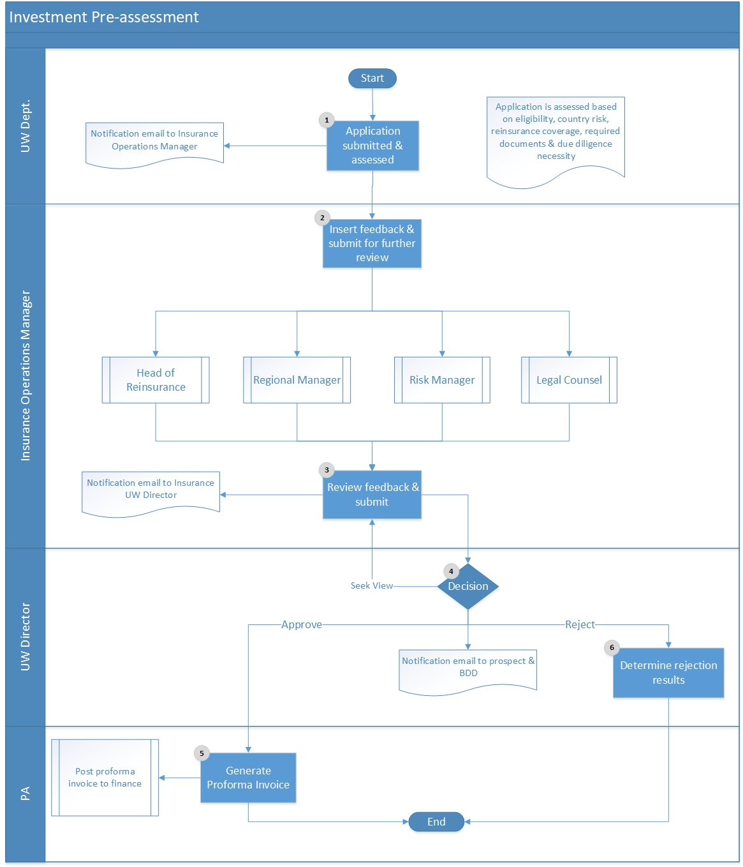

Figure ‎1-6 (Investment Pre-assessment)

Investment Pre-Assessment Flow Description

Step # | Stakeholder | Step | Description
1 | Underwriter  Senior Underwriter | Application Submission | Following the investment application registration process, a notification will be received on the system regarding the application. Upon assessment completion (assessment in terms of sharia compliance, eligibility, country risk and reinsurance coverage), details have been updated and necessary documents uploaded, the application is eventually submitted to the Manager for further review, feedback and processing.
2 | IO Manager  (Sovereign Risks) | Review | Insurance operations managers will review the application, feedback and submit it on the system to seek views from related ICIEC stakeholders. Request for input will be directed to Head of Reinsurance, Regional Manager, RMD, and Legal Counsel.
2 | IO Manager  (Commercial Risks) | Review
3 | Head of Reinsurance | Feedback | Associated stakeholders will review the submitted investment application and feedback. Accordingly, automatic notification will be directed to the Insurance UW Director and Insurance Operations Manager.
3 | Regional Manager | Feedback
3 | RMD | Feedback
3 | Legal Counsel | Feedback
3 | IO Manager  (Sovereign/Commercial Risks) | Review | Review all feedback received from stakeholders and submit to the Director, UW for decision
4 | Director Underwriting | Decision | If all the input provided is adequate, decision is taken on the investment pre-assessment application otherwise director may seek view and request more information.
5 | Assistant, UW (PA) Associate, UW (PA) | Approval | Upon approval, proforma invoice is generated from the system and shared with the client via automatic notification email in order to process the payment and complete the main application.
6 | Assistant, UW (PA) Associate, UW (PA) | Rejection | Upon rejection, decision and justifications are shared with the client via automatic notification email.

FII/Investment Application Evaluation Process

Purpose: Upon an investment application submission and once investment pre-assessment process has been accomplished, main application will be filled by the client to proceed with final arrangements of insurance coverage request.

Required Documents:
- Online application
- Investor’s latest audited annual financial statements
- Latest audited annual financial statements of the investor’s ultimate parent company
- KYC Report on the investor and the applicant
- Any feasibility study relating to the project, including cash flow projections and market analyses
- All documents relating to the investor’s contribution to the enterprise: (shareholder’s agreement, joint venture agreement, management agreement, technical assistance agreement, and loan guarantee agreement
- Latest audited annual financial statements
- All contracts relating to any non- equity direct investment (production-sharing contract, lease agreement and operating agreement
- All agreements with the host government and its agencies
- Approvals issued by the host government and its agencies
- Guarantee issued by the host government and its agencies
- All other agreements between the enterprise and third parties relating to this project on which the viability of the project is dependent.
- Underwriting Submission Memo

Involved Stakeholders:
- Client
- Senior Underwriter
- Underwriter
- Manager, Insurance Operations (Sovereign Risks)
- Manager, Insurance Operations (Commercial Risks)
- TUC Committee

FII/Investment Application Evaluation Flow Chart

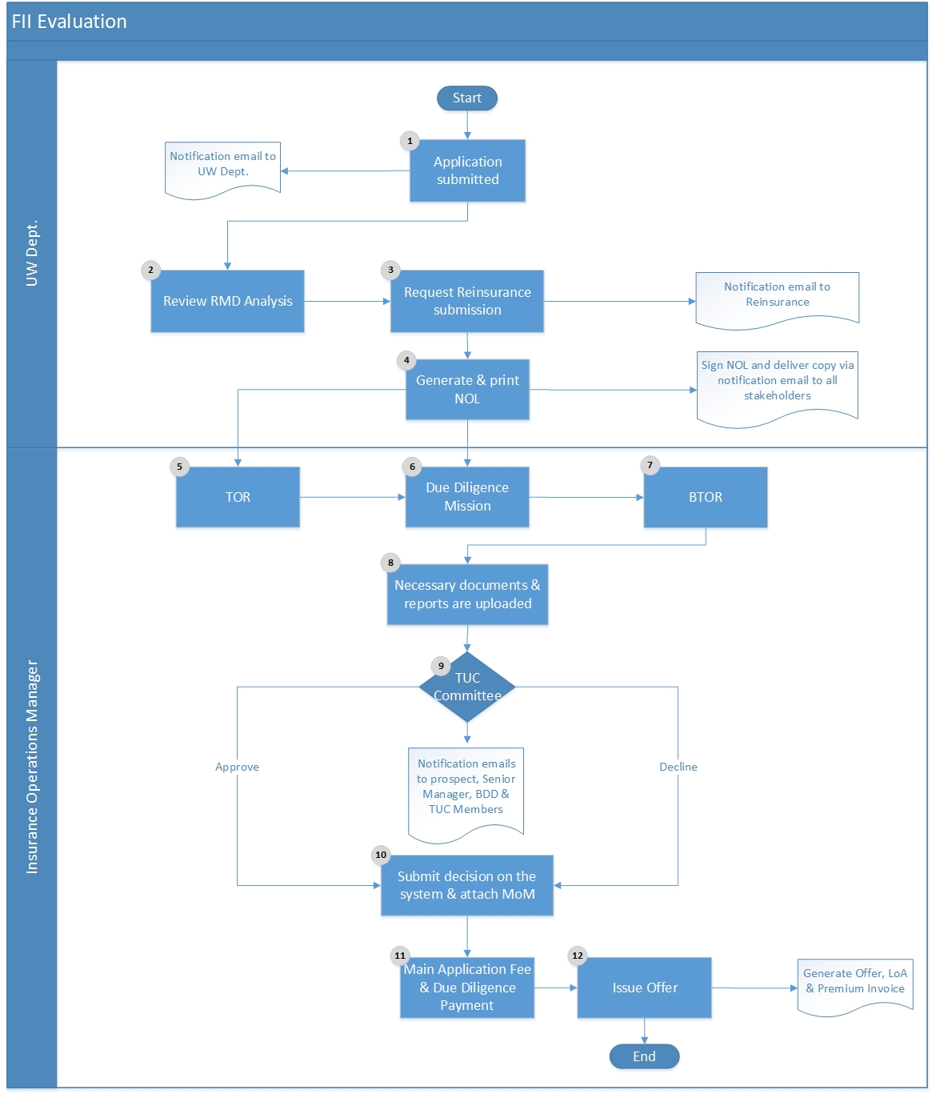

Figure ‎1-7 (FII Evaluation)

FII/Investment Application Evaluation Flow Description

Step # | Stakeholder | Step | Description
1 | Underwriter  Senior Underwriter | Application Submission | Following the investment pre-assessment process or the application registration process, a notification will be received on the system accordingly. Notification shall be directed to the Country Risk to prepare the TUC submission and Reinsurance Manager for necessary outward reinsurance arrangements.
2 | RMD | Review &  Feedback | RMD will review the application and all relevant details to prepare TUC submission.
3 | Head of Reinsurance | Review &  Feedback | Head of Reinsurance will review the application and take all necessary arrangements to seek for outward reinsurance (if needed).
4 | Underwriter  Senior Underwriter | NOL | Upon review and feedback of risk management and reinsurance departments, NOL shall be generated from the system, printed, approved, and signed based on DoA. Accordingly, NOL will be shared with all associated stakeholders via automatic notification email.
5 | Underwriter  Senior Underwriter | TOR | TOR shall be prepared by the Underwriter, approved by the Manager of Insurance Operation, then by the Underwriting Director and consists of the meetings and topics to be discussed during the mission which shall be eventually approved by the CEO.
6 | Underwriter  Senior Underwriter | Due Diligence | If a due diligence mission is required for detailed on-site review, necessary arrangements will be taken to plan accordingly.
6 | Underwriter  Senior Underwriter | BTOR | BTOR shall be prepared by the Underwriter, reviewed by the Manager, Insurance Operation, then circulated to Underwriting Director and CEO. It covers all aspects and outcomes of the due diligence mission.
6 | Underwriter  Senior Underwriter | Due Diligence  Report | Upon due diligence accomplishment, TUC submission for the committee shall be prepared and uploaded into the system.
7 | IO Manager  (Sovereign Risks) | Review | IO Manager (Sovereign/Commercial Risks) will receive notification that TUC submission has been attached for review to take proper action and decide on the TUC submission.
7 | IO Manager (Commercial Risks) | Review
8 | TUC Committee | Committee | TUC meeting is scheduled and committee attends to discuss the TUC submission along with Country Risk TUC.
9 | Underwriter  Senior Underwriter | Submit Decision | Record and upload the TUC Committee decision and relevant MoM into the system indicating all TUC members who have attended the meeting. In case of approval, offer will be generated, LoA and Premium Invoice will be issued. However, in case of rejection, then rejection letter shall be shared with the policyholder with clear and adequate justifications. Automatic notification emails shall be directed to all stakeholders and involved parties, including the Account Manager.

Policy Offer and Issuance Process

Purpose: After the ST evaluation process or the MLT/Investment application evaluation, the underwriter, receives an automatic notification on the system to prepare and generate the offer, issue premium invoices, and generate letter of acceptance. Following the approval of the offer by the client, the policy will be eventually issued and hard copies will be generated, printed, and delivered to associated stakeholders (client and ICIEC).

Required Documents
- Not Applicable

Involved Stakeholders
- Client
- Assistant, Underwriter (PA)
- Associate, Underwriter (PA)

Policy Offer and Issuance Flow Chart

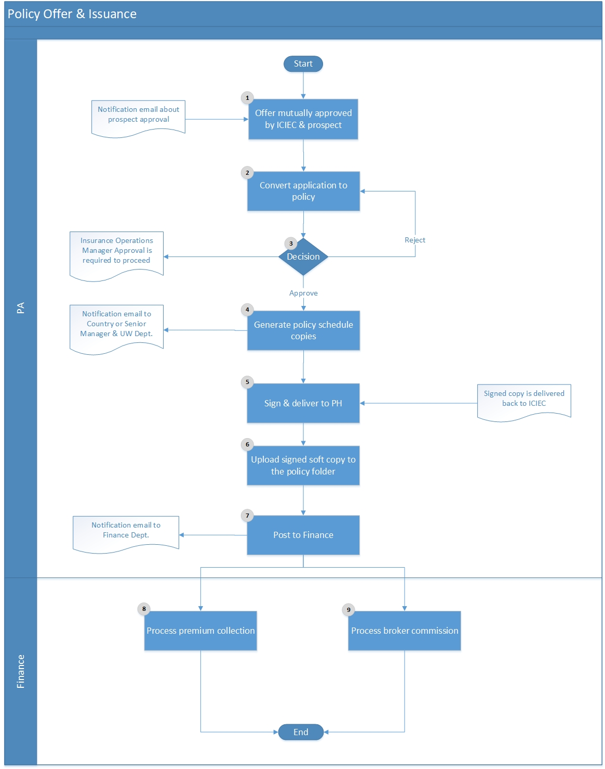
Figure ‎1-8 (Policy Offer & Issuance)

Policy Offer & Issuance Flow Description

Step # | Stakeholder | Step | Description
1 | Assistant, Underwriter (PA)  Associate, Underwriter (PA) | Issue Offer | Following the ST evaluation process or the MLT/Investment application evaluation, the underwriter receives notification on the system to prepare the offer, premium invoice, and generate LoA to be signed from the client.
2 | Assistant, Underwriter (PA)  Associate, Underwriter (PA) | Convert | Upon mutual approval of the offer by ICIEC and the client, application will be converted to policy.
3 | IO Manager  (Sovereign Risks) | Decision | Insurance Operations Manager will receive automatic notification for final review and approval is required to proceed. If rejected, policy offer will be returned back to the underwriter otherwise policy issuance shall occur.
3 | IO Manager  (Commercial Risks) | Decision
4 | Assistant, Underwriter (PA)  Associate, Underwriter (PA) | Print | Upon approval, policy schedule and relevant reports shall be generated from the system and print two hard copies.
5 | Assistant, Underwriter (PA)  Associate, Underwriter (PA) | Signature | Policy hardcopies will be sent to the CEO’s office for signature and then delivered to the client by courier.
6 | Assistant, Underwriter (PA)  Associate, Underwriter (PA) | Upload | Once documents have been signed by the client and one copy has been delivered back to ICIEC, it shall be scanned and uploaded into the system. The original signed copy shall also be delivered to the Legal Department for archiving purposes.
7 | Assistant, Underwriter (PA)  Associate, Underwriter (PA) | Premium | Upon finalization, premium invoice shall be generated and directed to the Financial entity and Financial department is automatically notified to collect associated premiums.
8 | Assistant, Underwriter (PA)  Associate, Underwriter (PA) | Commission | Upon finalization, along with premium invoice directed to the Financial entity, payable commissions to brokers (if any) are also issued and Financial department is automatically notified.

Policy Renewal Process

Purpose: Policies that have expired or about to expire within a certain period ahead can be renewed whereby the Policy Administrator is required to gather all information from the policyholder prior to renewal in order to review and evaluate. If on the basis of such review, the underwriter is in favour of renewing the policy under the same conditions, thirty days before expiry of policy, a letter should be sent to the policyholder advising that the policy is automatically renewed for further period as stipulated in the provisions of the policy. However, if ICIEC wishes to cancel the policy, it must give written notice to the policyholder at least 30 days prior to the renewal date. Nevertheless, the policyholder may cancel the policy at any renewal date by giving prior written notice.

Required Documents
- Not Applicable

Involved Stakeholders
- Client
- Assistant, Underwriter (PA)
- Associate, Underwriter (PA)
- Underwriter
- Senior Underwriter
- GLC

Policy Renewal Flow Chart

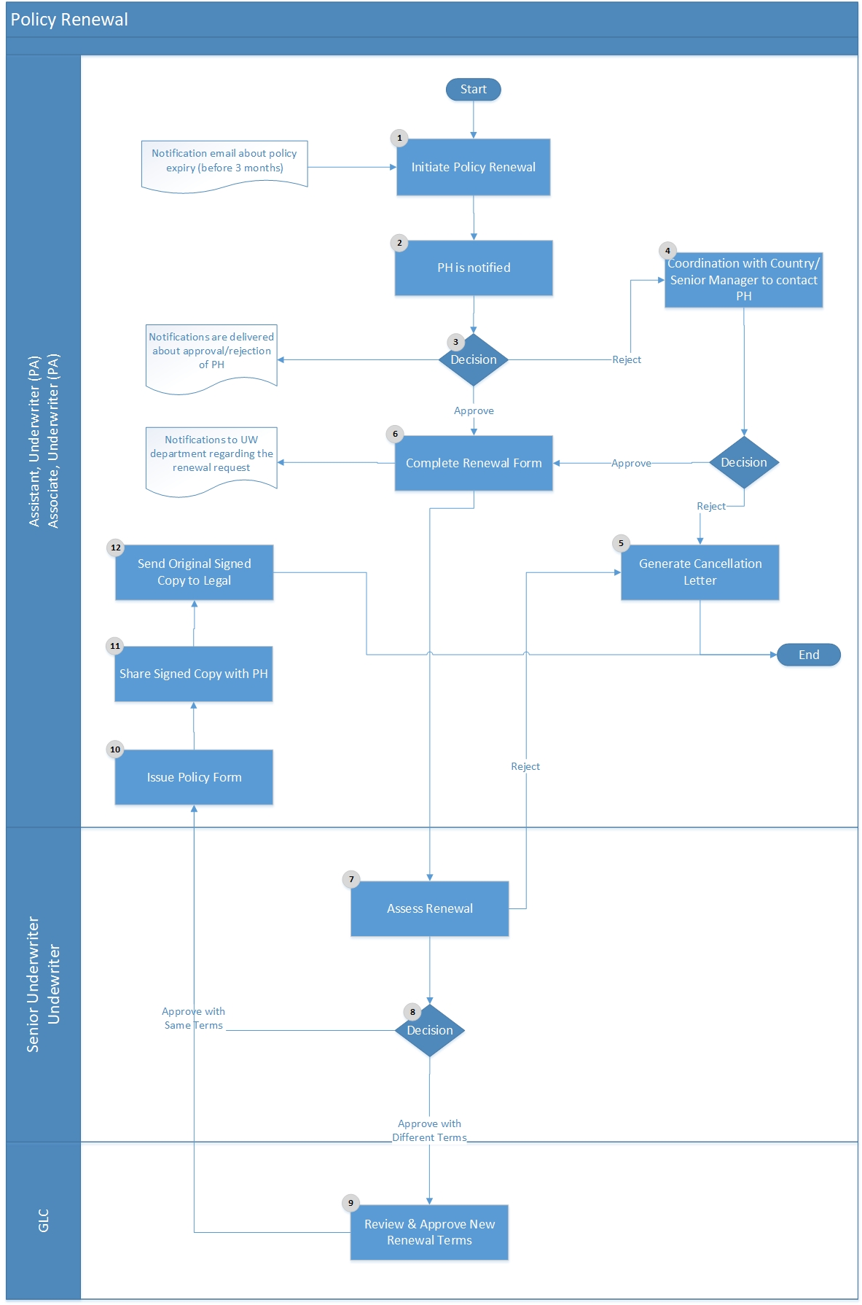

Figure ‎1-9 (Policy Renewal)

Policy Renewal Flow Description

Step # | Stakeholder | Step | Description
1 | Assistant, Underwriter (PA)  Associate, Underwriter (PA) | Initiate Policy Renewal | Before three months of expiry date, a notification will be received on the system for renewal of a policy and policy renewal process will be initiated on system.
2 | Assistant, Underwriter (PA)  Associate, Underwriter (PA) | PH Notification | PH will be automatically notified for the renewal request status and shall decide on the renewal.
3 | Assistant, Underwriter (PA)  Associate, Underwriter (PA) | PH Decision
4 | Assistant, Underwriter (PA)  Associate, Underwriter (PA) | Coordination | Upon rejection of PH to renew the policy, coordination with the Country/Senior Manager who is responsible to negotiate with the PH shall take place.
5 | Assistant, Underwriter (PA)  Associate, Underwriter (PA) | Reject | Upon final rejection of PH, notification of Cancellation Letter and Customer Survey link to enter feedback and evaluation of experience with ICIEC will be directed to the PH.
6 | Assistant, Underwriter (PA)  Associate, Underwriter (PA) | Renewal Form | Complete the Renewal Form on the system and submit it whereby automatic notifications will be directed to the UW department for follow-up and further processing.
7 | Senior Underwriter  Underwriter | Assessment | Assessment of the Renewal Form will take place whereby renewal might be rejected, renewed with the same terms or renewed with different terms.
8 | GLC | Assessment | Review and approve the renewal policy with the new terms.
9 | Assistant, Underwriter (PA)  Associate, Underwriter (PA) | Issue Policy Form | Issue the Policy from system, print it and get it signed.
10 | Assistant, Underwriter (PA)  Associate, Underwriter (PA) | Share Copy | Share the signed copies with PH via email and save it.
11 | Assistant, Underwriter (PA)  Associate, Underwriter (PA) | Send to Legal | Send the original signed copy to Legal Department for archive.

Endorsements Process

Purpose: During the policy period, the policyholder may request additional modifications on active policies. Any change on the policy information during policy period should go through an endorsement transaction process in order to keep and maintain full history of requested and applied amendments. The supported policy administration transaction can be classified to technical transactions that affect premium and require UW or non-technical ones that neither have a financial impact nor require UW.

Endorsement | Classification
Policy Cancellation | Technical
Term/Tenor Modification | Non-Technical
Policyholder Personal Details Modification | Non-Technical
Loss Payee Assignment | Non-Technical
Subsidiaries Addition/Modification | Non-Technical
Risks Addition/Modification | Technical
Terms and Conditions addition/Modification | Non-Technical

Required Documents
- Not Applicable

Involved Stakeholders
- Client
- BDD
- Assistant, Underwriter (PA)
- Associate, Underwriter (PA)
- Underwriter
- Senior Underwriter
- GLC

Endorsements Flow Chart

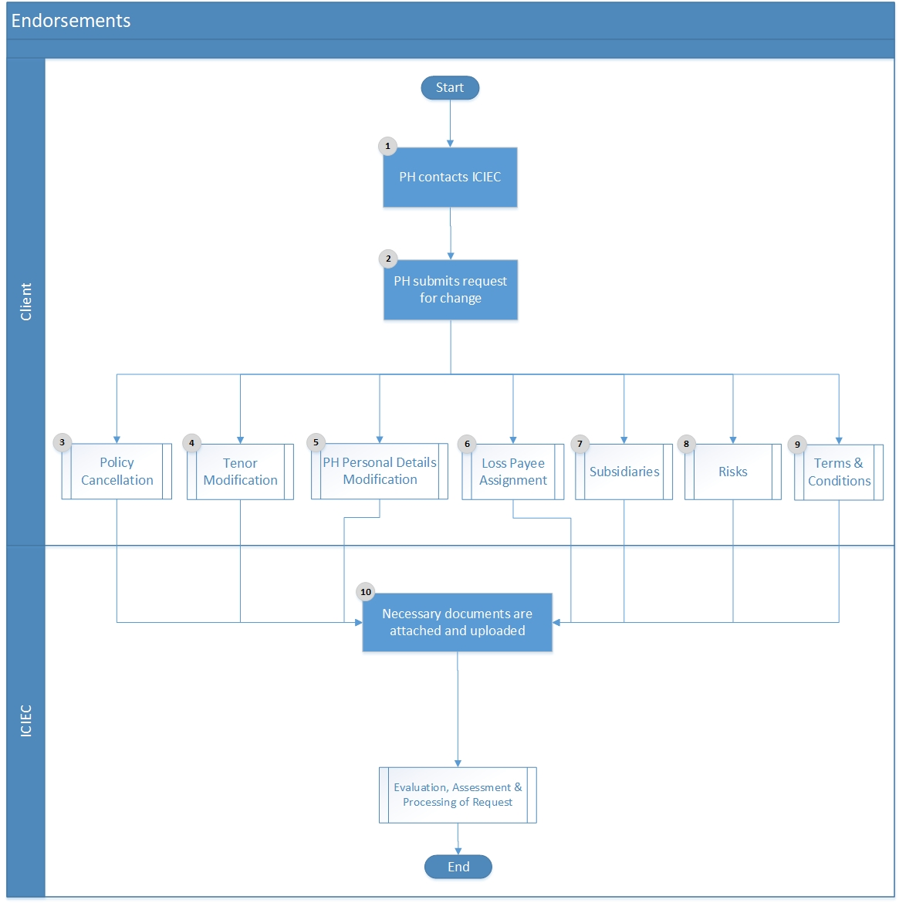

Figure ‎1-10 (Endorsements)

Endorsements Flow Description

Step # | Stakeholder | Step | Description
1 | Policyholder | Contact | Policyholder will contact ICIEC (account manager) and submit a request for change. According to the submitted request’s nature, notification emails will be directed to the associated parties (e.g. Change of Terms & Conditions shall be directed to GLC etc.).
2 | Policyholder | Submit Change
3 | Policyholder | Documents | Along with submitted change request, policyholder shall provide and upload all necessary documents. Accordingly, automatic notification emails shall be directed to the UW department, GLC, PA, RDM, Reinsurance and BDD.
4 | ICIEC | Assessment | Assessment of the request will take place by the respective stakeholders whereby change might be rejected, negotiated or accepted. Accordingly, automatic notifications will be delivered to all involved parties

Notification of Probable Loss Process

Purpose: Based on probable and high risk of losses or if an entity (buyer, bank, Government etc.) did not pay during the agreed upon payment period (without having a previous extension request), it is extremely important and mandatory that the NPL is made as earlier as possible, as only with such a notification ICIEC can react. If the notification was not made or made after the due date required, it is possible that ICIEC grants new cover for another policyholder and runs into additional losses if the buyer is bankrupt. Also, policyholder is required to submit NPL request, if the payment period was extended twice for a particular buyer.

Required Documents:
- Online NPL application form
- Communications with Buyer (via email, via courier etc.)
- Evidence and reasons for payment delays
- Documentation of all related information about the probable loss and due dates
- Acknowledgement of the overdue notification: within the grace period of 30/60 days after the due date of payment.

Involved Stakeholders:
- Policyholder
- Underwriter
- Senior Underwriter
- Associate, Claims and Recovery
- Head, Claims and Recovery
- RMD
- NPL Committee
- Finance Department

NPL Submission Flow Chart

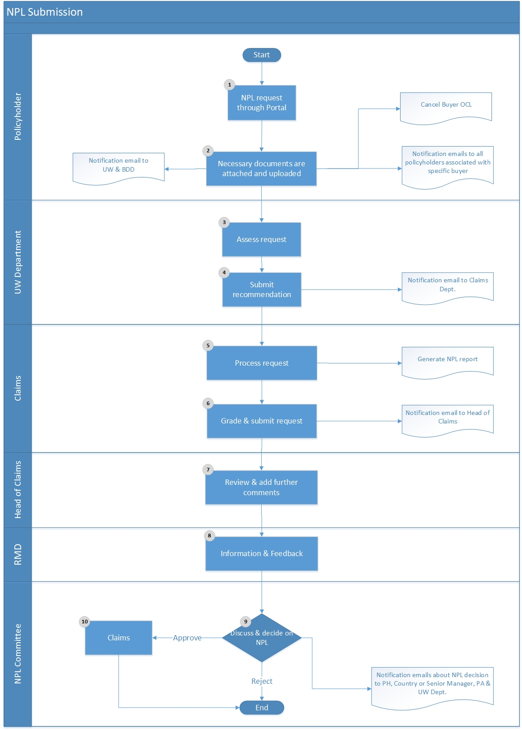

Figure ‎1-11 (NPL Submission)

NPL Submission Flow Description

Step # | Stakeholder | Step | Description
1 | Policyholder | NPL Request | Authenticated policyholder shall log onto ICIEC website and through online customer portal, they will submit the Notification of Probable Loss.
2 | Policyholder | NPL Documents | Along with submitted NPL, policyholder shall provide and upload all necessary documents. Accordingly, automatic notification emails shall be directed to the UW department and BDD.
3 | Underwriter  Senior Underwriter | Assessment | Underwriter will perform necessary assessment upon provided details and documents.
4 | Underwriter  Senior Underwriter | Recommendation | Underwriter recommendations and observations will be submitted and inserted into the system. Accordingly, automatic notification emails shall be directed to all policyholders associated with the particular buyer to be alerted in addition to Claims department for further processing.
5 | Associate  Claims and Recovery | Process | Preparation of NPL Report on the system and submit it to the Head, Claims and Recovery.
6 | Associate  Claims and Recovery | Grade | Implementation of NPL grading and submit it to the Head, Claims and Recovery. NPL grading is a set of pre-defined grading with a list of criteria for the Associate, Claims, and Recovery to choose from and can be utilized in the provisioning process.
7 | Head  Claims and Recovery | Review | Head of Claims and Recovery will receive automatic notification that the NPL is ready for review and can add extra comments (if any). Upon finalization, NPL will be directed to the NPL committee to decide upon and to reinsurance function for reinsurers notification e.g. for NPL exceeding $500k and $1.5m respectively in the ST and MT/FII treaty.
8 | NPL Committee | Decision | NPL Committee shall be assembled to discuss on pending NPLs and decide upon. If rejected, a rejection letter shall be directed to the policyholder with clear justifications. Committee decision shall also be shared with Country or Senior Manager, Policy Administrator, and UW Department.
9 | NPL Committee | RMD | RMD will assess the residual risk and potential Probable of Default (PD) and Loss Given Default (LGD) relating to NPL, provide feedback and use the calibration for internal portfolio risk analytics.
10 | NPL Committee | Claim | If NPL is approved by NPL Committee, a notification shall be directed to the policyholder stating that the NPL request is under process, further details will be required and Claims and Recovery will get in contact. In addition, the policyholder is required and asked to minimize and/or avoid losses, in order to avoid reaching the claim state. Eventually, integration occurs with the Financial entity to generate respective journal vouchers whereby money is set aside to pay policyholders who have filed or are expected to file legitimate claims on their policies.

Claim Submission Process

Purpose: When debts are not paid by buyers at the respective due dates, policyholders must inform ICIEC immediately as only with such information ICIEC can react prudently and take the necessary risk mitigating measures. Moreover, for a claim to be valid and legible, the insured party needs to prove that all required rules were applied. Both NPL and claims must be submitted online via the Customer Portal however validation must be in place to assured that no due premiums are pending.

Required Documents
- Online Claim application form (e.g. current limit conditions, policy conditions and terms, fraud transaction, no. of claims were paid previously, disputes between (PH) and buyer etc.)
- Communications with Buyer (via email, via courier, etc.)
- Evidence and reasons for payment delays
- Documentation of all related information about the probable loss and due dates

Involved Stakeholders
- Policyholder
- Underwriter
- Senior Underwriter
- Associate, Claims and Recovery
- Head, Claims and Recovery
- Claims Committee
- Finance Department

Claim Submission Flow Chart

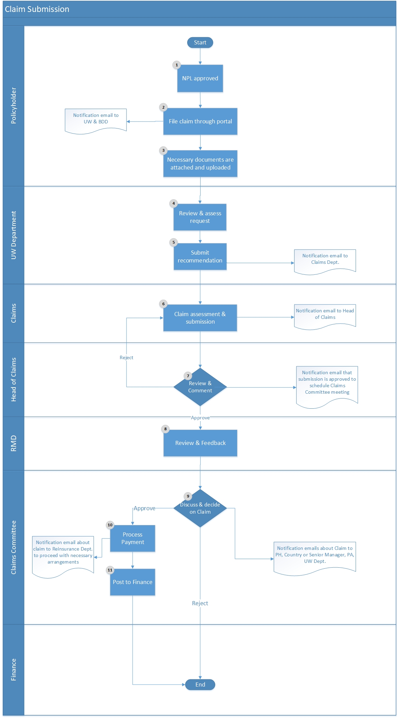

Figure ‎1-12 (Claim Submission)

Claim Submission Flow Description

Step # | Stakeholder | Step | Description
1 | Policyholder | NPL Approval | Providing that policyholders have submitted NPLs upon high probability of loss and the NPLs have been approved, they become eligible for claims’ filing in case of actual loss occurrence.
2 | Policyholder | Claim Request | Authenticated policyholder shall log onto ICIEC website and through online customer portal, they will submit the Claim request providing that NPL has been previously submitted and approved. Accordingly, automatic notification emails shall be directed to the UW department and BDD.
3 | Policyholder | Claim Documents | Along with submitted claims, policyholder shall provide and upload all necessary documents and evidences.
4 | Underwriter  Senior Underwriter | Assessment | Underwriter will perform necessary assessment upon provided details and documents.
5 | Underwriter  Senior Underwriter | Recommendation | Underwriter recommendations and observations will be submitted and inserted into the system. Accordingly, automatic notification emails shall be directed to all policyholders associated with the particular buyer to be alerted in addition to the Claims department for further processing.
6 | Associate  Claims and Recovery | Assessment | Claim assessment and submission to Head of Claims and Recovery. In addition, claim submission for the Claims Committee shall be prepared and uploaded onto the system.
7 | Head  Claims and Recovery | Review | Head of Claims and Recovery will receive automatic notification that the claim is ready for review and addition of extra comments (if any). Upon finalization and approval, claim will be directed to the Claim committee to decide upon.
8 | RMD | Review and Feedback | RMD will assess the actual claim risk, weigh it on the Probable of Default (PD) and Loss Given Default (LGD) data. RMD also provides feedback and use for lesson learned perspectives as well as calibration for internal portfolio risk analytics
9 | Claim Committee | Decision | Claim Committee shall be assembled to discuss on pending Claims and decide upon. If rejected, a rejection letter shall be directed to the policyholder with clear justifications.
10 | Associate  Claims and Recovery | Approval | If Claim is approved by Claim Committee, a notification shall be directed to the policyholder stating that the Claim request is approved and payment will be issued. Reinsurance function needs to be advised as reinsurers need to be notified 1 month prior to any claim’s payment to the policyholder, in case cash call is required for claims exceeding $1m and $1.5m in the ST and MT/FII treaties respectively.
11 | Associate  Claims and Recovery | Payment | Eventually, integration occurs with the Financial entity to generate respective payment vouchers. Before a claim’s payment is made, Financial department’s staff must check whether there are any payment arrears for the policyholder. If so, then, outstanding due premiums should be deducted from the claim’s payment in favour of the policyholder and pay out only the balance.

Overall Credit Limit (OCL) Process

Purpose: Using credit control management techniques and internal credit management processes, a credit limit is specified and granted representing the maximum insured credit line for a specific buyer/bank. Policyholders are bound to it and can trade on an insured basis within the approved credit limit throughout the policy period bearing in mind that annual OCL monitoring is necessary and sufficient. However, in extraordinary situations like rating deterioration or on other negative information an “ad-hoc monitoring” should also be performed.

Nevertheless, Policyholder Premium Credit Limit (PPCL) might also be controlled through integration between new policy/declarations and Accounts Receivable whereby if PH exceeds the associated PPCL, then system should reject additional declarations and request to settle or request higher PPCL through their account manager.

Required Documents
- Credit report
- Audited financials
- Trading and Payment Experience
- KYC
- Updated sector report
- Updated country report

Involved Stakeholders
- Manager Underwriting, Commercial Risks
- Director Underwriting
- CEO
- Underwriter
- Senior Underwriter

Overall Credit Limit Flow Chart

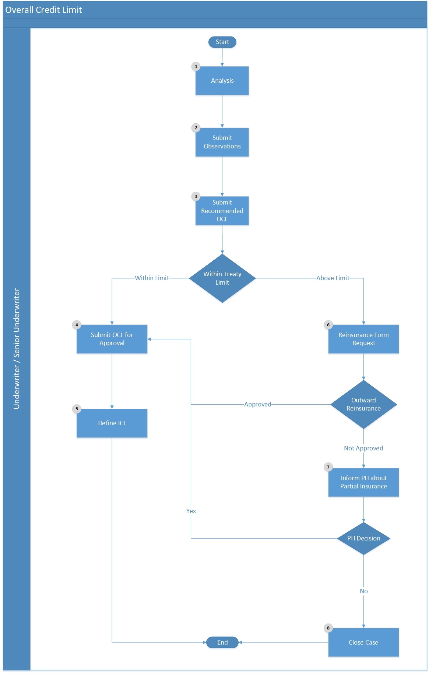

Figure ‎1-13 (Overall Credit Limit)

Overall Credit Limit Flow Description

Step # | Stakeholder | Step | Description
1 | Underwriter  Senior Underwriter | Analysis | An automatic email notification will be delivered in order to evaluate the buyer and perform necessary analysis.
2 | Underwriter  Senior Underwriter | Observations | According to the analysis performed, Underwriter will submit observations.
3 | Underwriter  Senior Underwriter | Recommend OCL | Eventually, recommended and concluded OCL will be submitted.
4 | Underwriter  Senior Underwriter | Submit OCL | Validation will take place to identify whether the recommended OCL falls with treaty limit or not. If yes, then OCL will be submitted and RMD will be notified at the stage of OCL approval on limit check purpose based on internal thresholds.
5 | Underwriter  Senior Underwriter | Define ICL | Once OCL has been successfully submitted, the pre-approved ICL will also be specified.
6 | Underwriter  Senior Underwriter | Reinsurance Request | If recommended OCL falls beyond treaty limit, reinsurance request form shall be filled and directed to the respective department in order to seek for outward reinsurance.
7 | Underwriter  Senior Underwriter | Inform | For cases, where no outward reinsurance is available, only partial insurance will be provided and policyholder will be informed accordingly in order to make decision whether to proceed with the partial limit or not.
8 | Underwriter  Senior Underwriter | Closure | If policyholder chooses to reject partial insurance, then case will be closed with specification of reasons.

Individual Credit Limit (ICL) Process

Purpose: Individual Credit Limits requested for each buyer/bank/guarantor shall fall within the approved respective OCLs. However, ICLs approval should proceed according to the DoA for the process. Nevertheless, Business Development department may issue ICLs (according to the DoA) within the pre-approved ICL by the UW for each buyer/bank/guarantor.

Required Documents
- Signed and Stamped CLA (Credit Limit Application)

Involved Stakeholders
- Policyholder
- Country Manager
- Senior Country Manager
- Underwriter
- Senior Underwriter
- Underwriting Manager

Individual Credit Limit Flow Chart

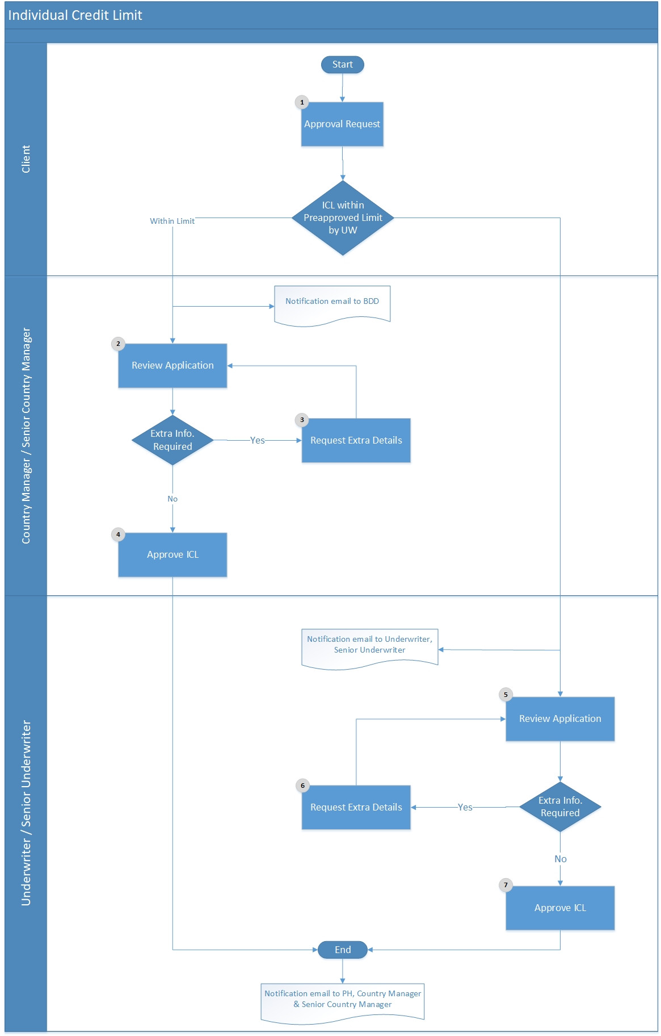

Figure ‎1-14 (Individual Credit Limit)

Individual Credit Limit Flow Description

Step # | Stakeholder | Step | Description
1 | Policyholder | Approval Request | Client will request to add a new buyer or increase the limit on an existing one.
2 | Country Manager  S. Country Manager | Review | If the requested ICL falls within pre-approved limit by UW, then automatic email notification will be delivered to Country Manager and Senior Country Manager to review the case.
3 | Country Manager  S. Country Manager | Extra Info. | If extra details and information are required, Country Manager or Senior Country Manager may consult the UW.
4 | Country Manager  S. Country Manager | Approve | Once details are adequate and verified, ICL will be approved and automatic email notifications will be delivered to the PH and Underwriting Manager.
6 | Underwriter  Senior Underwriter | Review | If the requested ICL falls beyond pre-approved limit by UW, then automatic email notification will be delivered to Underwriter and Senior Underwriter to review and evaluate the case.
7 | Underwriter  Senior Underwriter | Extra Info. | If extra details and information are required, Underwriter and Senior Underwriter will determine the needs.
8 | Underwriter  Senior Underwriter | Approve | Once details are adequate and verified, ICL will be approved and automatic email notifications will be delivered to the PH, Underwriting Manager in addition to Country Manager and Senior Country Manager.

Processes Authority Matrix
Bearing in mind that the processes flow & approval limits can be dynamically configured.
# | Process | Initiation | Review | Submission | Decision 1 | Decision 2 | Decision 3
1 | Entities Profile  (Policyholder, Broker, Local Agent, Reinsurer etc.) | Underwriting Support |  | Head, Underwriting Support | Head, Underwriting Support
2 | Credit Information Services | Underwriting Support | Head, Underwriting Support |  | Underwriting Support
3 | Portfolio Assignment | Managers
4 | NBI-Short Term | Sales Officer | Zone Manager | Underwriter | Manager, Commercial/Sovereign Underwriting
5 | NBI-Medium Term | Sales Officer | Zone Manager | Underwriter | Manager, Commercial/Sovereign Underwriting
6 | Policy Application | Policy Administration Officer | Head, Underwriting Support | Underwriter | Manager, Commercial or Sovereign Underwriting
7 | Policy Renewal | Policy Administration Officer | Head, Underwriting Support | Underwriter | Manager, Director or CEO
8 | Enquiry-Investment Insurance (Long Term) | Sales Officer | Zone Manager | Sales Officer | Manager, Sovereign Underwriting
9 | Preliminary Application Registration | Underwriting Support |  | Underwriter | Manager, Sovereign Underwriting | Director | CEO
10 | Main Application Submission / Policy Issuance | Underwriting Support | Head, Underwriting Support | Underwriter | Manager, Sovereign Underwriting | Director | CEO
11 | Investment Insurance-Renewal | Underwriting Support | Head, Underwriting Support | Underwriter | Manager, Sovereign Underwriting
12 | OCL (Buyer/Bank) | System / Underwriting Support |  | Underwriter | Manager, Underwriting | Director | CEO
13 | Credit Limit Approvals | Underwriting Support | Head, Underwriting Support | Underwriter | Manager, Underwriting
14 | Premium Invoice (Credit Note) | Policy Administration Officer | Head, Underwriting Support
15 | Fees Invoice (Credit Note) | Policy Administration Officer | Head, Underwriting Support
16 | Loss Payee Assignment | Policy Administration Officer | Head, Underwriting Support | Underwriter | Manager, Underwriting
17 | NPL (Notification of Probable Loss) | Underwriting Support | Head, Underwriting Support | Underwriter | Manager, Underwriting
18 | Claims | Claims Officer |  | Claims Officer | Claims Committee / Manager

Approvals

ESKADENIA Project Manager | ICIEC - Project Manager
Name : Ms. Laisan Mobaideen  Date :  Signature :_ _ _ _ _ _ _ _ _ _ _ _ _ _ | Name : Mr. Mohamad El Sayed  Date :  Signature :_ _ _ _ _ _ _ _ _ _ _ _ _ _ _
ESKADENIA Product Manager
Name : Mr. Radwan Al-Jundi

Date :

Signature :_ _ _ _ _ _ _ _ _ _ _ _ _ _

